**CS5551**

**Spring 2015**

**Advanced Software Engineering**

**Project Increment II (PG-9)**

**Title: Virtual Learning**

**Submitted by:** Bala Sai Teja Gaddam (Class ID: 15)

Teja Mosali (Class ID: 34)

Manisha Kattukuri (Class ID: 27)

Tejaswini Nalamotu (Class ID: 35)

1. **Objectives:**

Education is important for everyone in their daily life in order to improve their skills and knowledge in the fields which they are interested in. Now-a-days most of the exams are conducted virtually that is they are conducted online rather than paper based. We are providing an application called as Virtual Learning which provides solutions to the problems arises with the paper based examinations. Through this application we are providing the users with the information about tutors in their specific field and we are also providing the required materials in their field of interest. By using this application students can help themselves in managing time and they can assess themselves about their knowledge in that field.

1. **Import Existing Services/API:**

To develop this application we have used Visual Studio as our Integrated Development Environment. Distinct functionalities can be provided with the help of ASP.Net web form templates. The backdrop of all pages can be given in Master page. Cascading style sheets are also used as the style for master sheet. Each and every page will be completely based on master page and web pages will be inherited from the master page itself in order to have look and feel.

We are using a google MAP API in our project. This API is used to get the addresses of the tutors which we are providing in this application. We are also using Google Search API in this application. This is used to search any topics, materials, queries and many more.

1. **Detail Design of Services:**
2. **User Stories:**

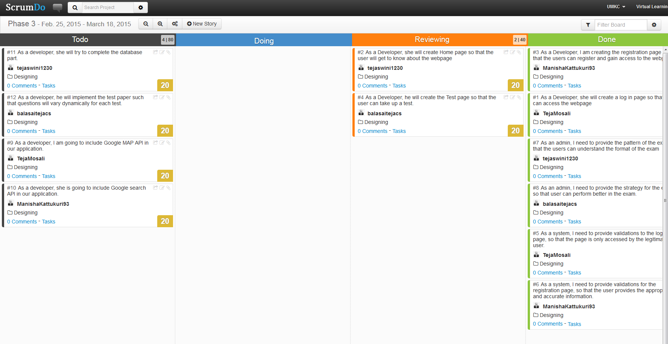

1. **Service Description:**

In this project, applications will be created with Visual Studio.Net. The web services of ASP.NET can be easily understandable. For building the web services and web applications ASP.NET is preferably used. Some of the web protocols which have been used for standard based technologies like Hyper Text Transfer and Extended Markup Language are simple object success protocols. The template which helps in creating a web application is ASP.NET web form template, it provides the provider below characteristics. These templates offers some functionalities discussed below.

* CSS
* Ajax scripting with JQuery
* Home or master page
* Login security is provided by using ASP.NET
* Navigation with help of menu control

Following are the features which are provided by default by this template,

* Web.config file
* Master or home page
* Package.config file
* One global application class
* Folder which contains CSS files along with client script files and membership pages

1. **Sequence Diagram:**

**Admin:**



**Student:**



1. **Class Diagram:**



1. **Screenshots and Explanation:**
2. **Master Page:**

This is the centralized part of our application. By using Cascaded style sheets, we have provided styles for this master page. In this increment we have concentrated on connecting the database to this master page. We have designed a basic User Interface for this page. In next increment we will improve the appearance of this master page. The basic User Interface for this master page is as shown below.

1. **User Registration Page:**

If a new user wants to access this application to take any test or to gain access to any provided material, he/she needs to register him/herself to this application primarily. In order to register themselves for this application they need to provide information such as Name, Password and Email Id. After registering for the application they can log in to access the application. Now they are able to take tests and can view the related material and tutor’s information provided. We have connected this page to the data base and implemented the validations for this page. If anyone without giving all the desired details cannot be able to register themselves to this application. It will produce an error message saying some fields need to be filled in order to register.

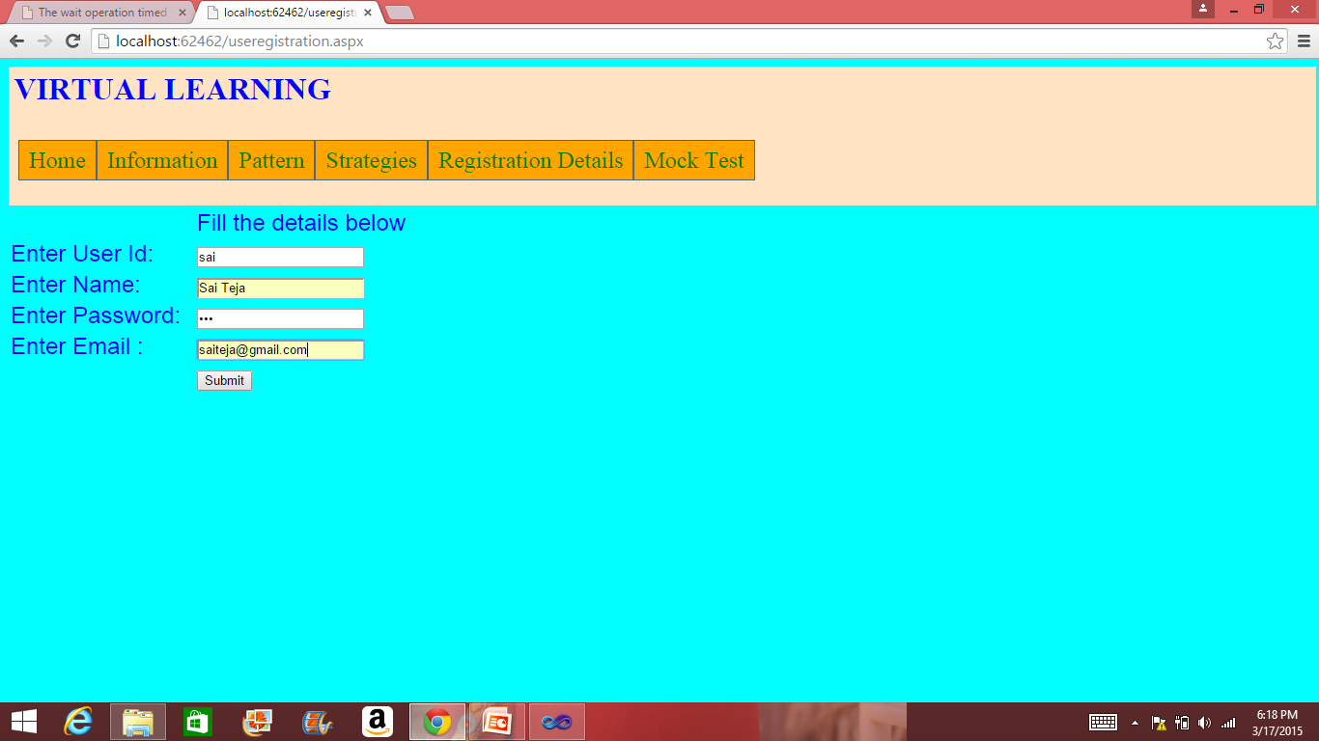

If all the fields of registration details are not mentioned,

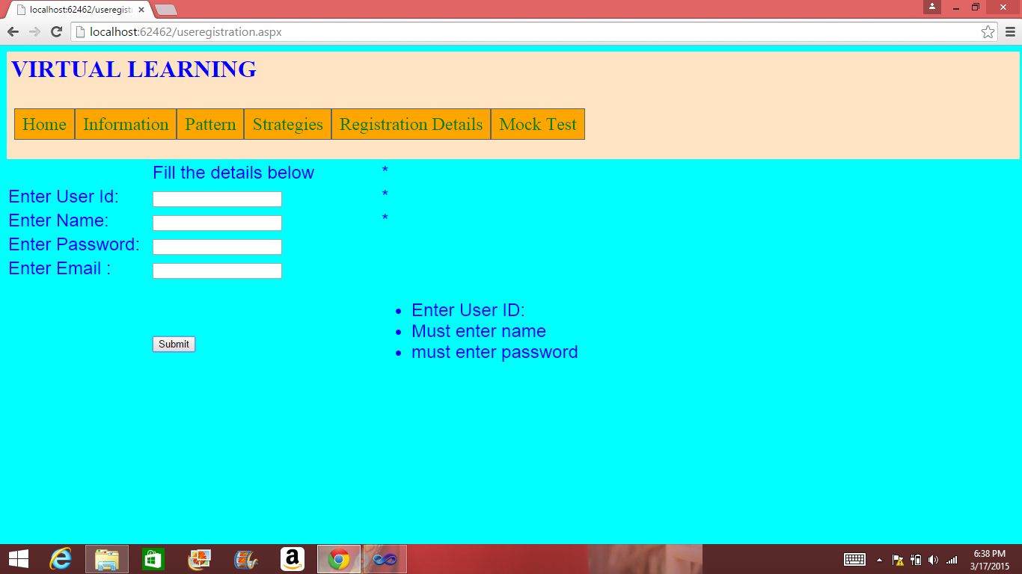

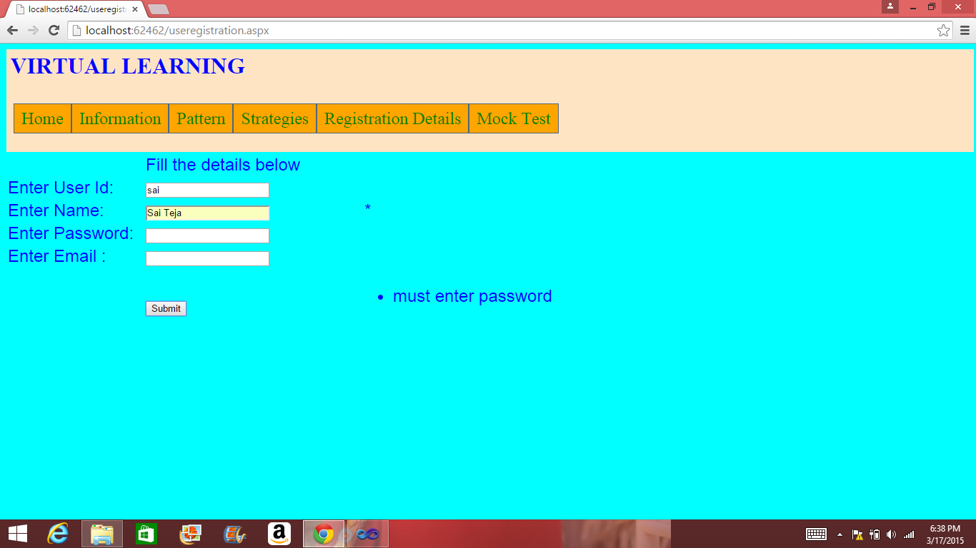

1. **Login Page:**

This age is used to access the application if the user is already registered. User need to provide their username along with the password they have created while registering for this application in order to gain access and take tests. If the user is not a registered user, then the there is a link provided which will direct the user to the registration page. We have provided the validations for this page. If a user gives wrong username or password then error will be generated saying username or password is wrong.

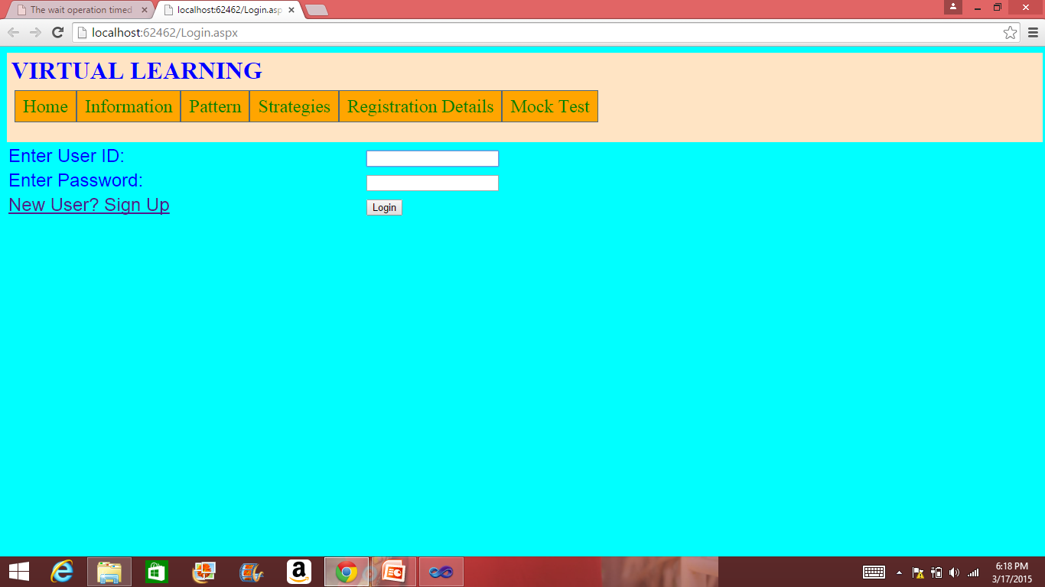

If all details are not given then it will generates error message as following,

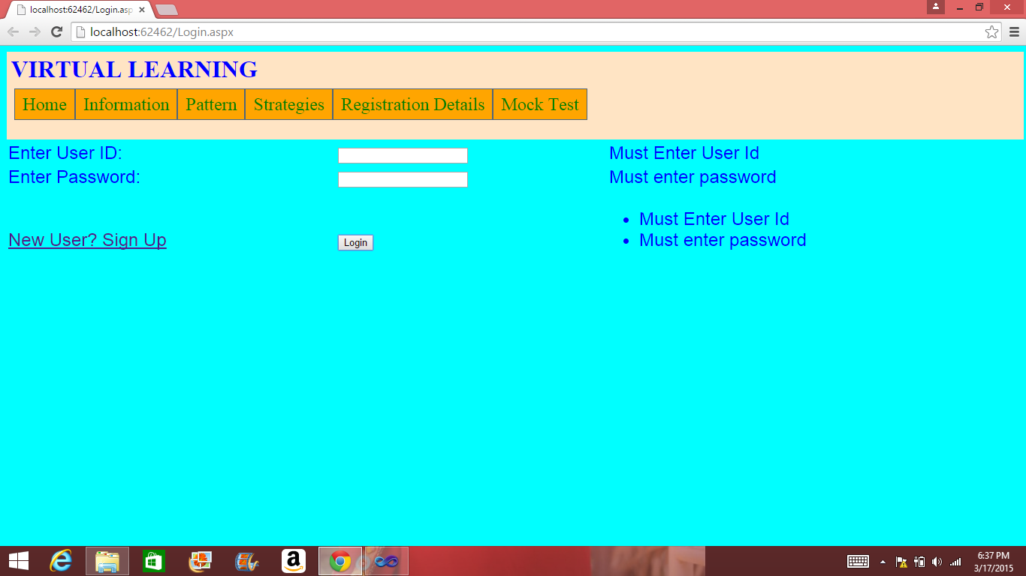

1. **Information Page:**

This page gives the overall information about the application. The areas or fields in which exams are conducted and the services which are provided by this application is discussed in detail in this page.

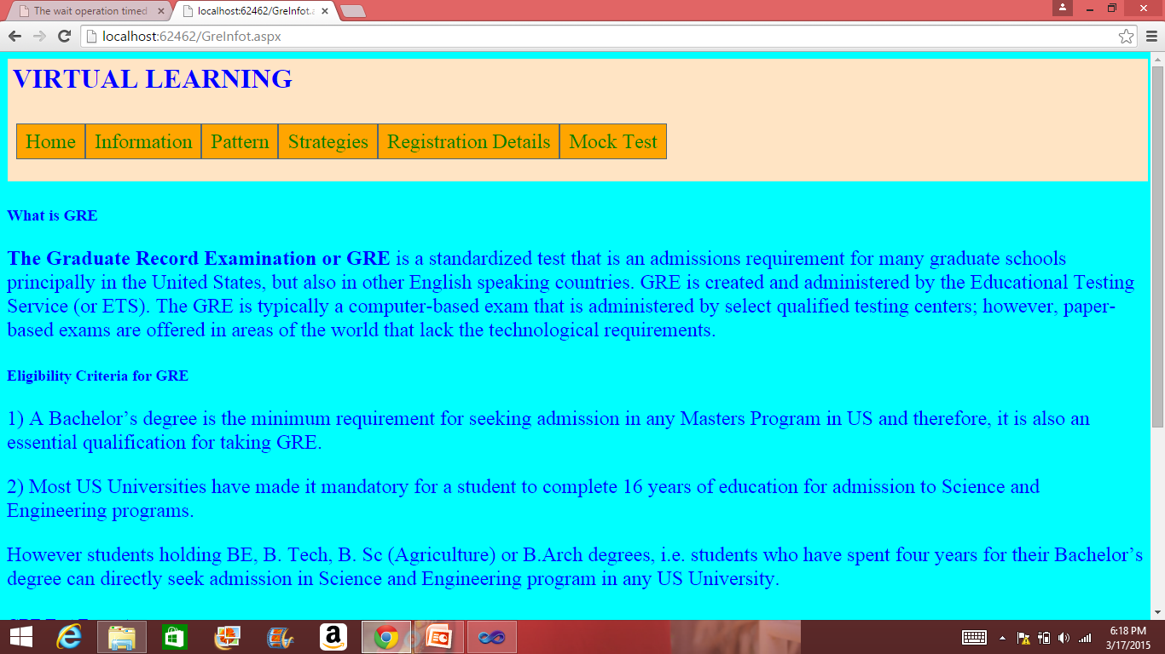

Information of GRE

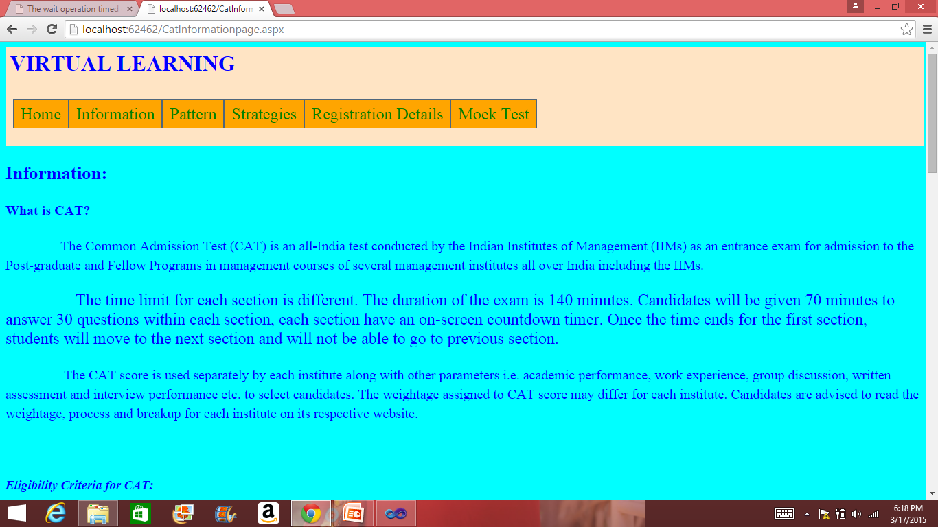

Information of CAT

1. **Pattern:**

In order to write any test we need to know the pattern for the test. In this page the pattern for the tests has been discussed. In this page we have given pattern for GRE as well as CAT. We have provided what are the topics which are going to be covered in this area and the sub sections of the test. The time limitation for the test is also provided to the users in this page.

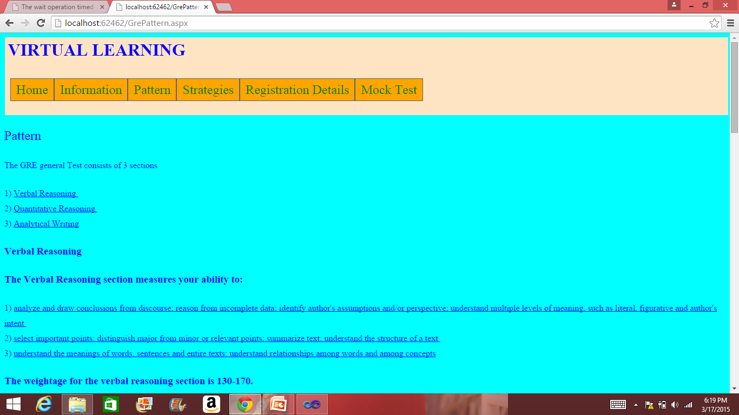

Pattern of GRE

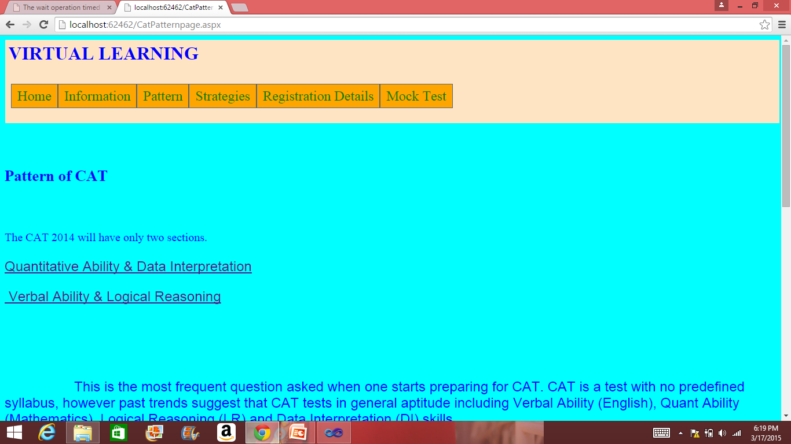

Pattern of CAT

1. **Strategies:**

To write any exam effectively we to have some strategies in mind to write the exam. By keeping this in mind we have researched this area and how can we improve the results of the user. We came up with some strategies to help the users to improve their performance in exam. Every test has its own strategy, so we have provided different strategies for both GRE and CAT.

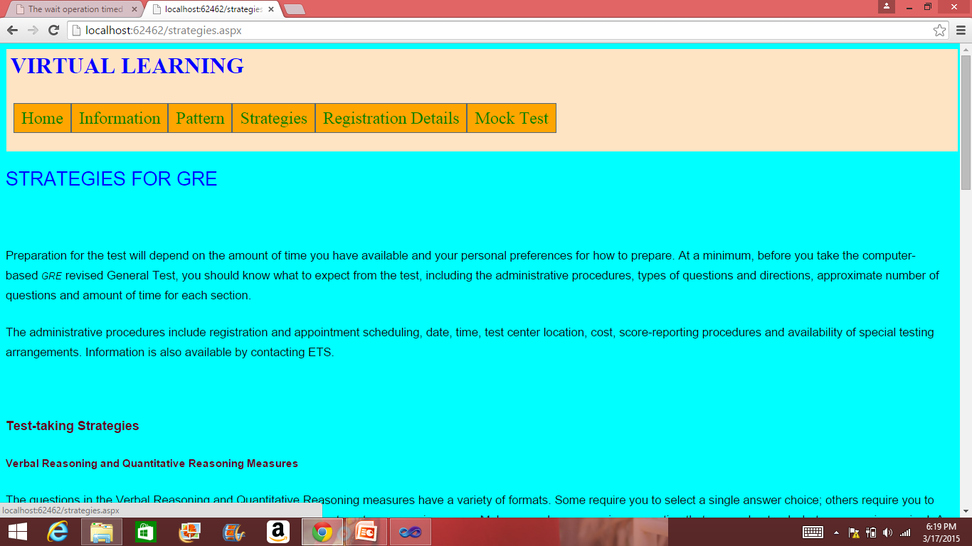

1. **Registration Details:**

In order to take any test, every user need to register for that particular test in advance. There are different ways to register for different tests. Registration for GRE is different from registration for CAT. We have given information for registering for these tests in detail in this page for users. This will give overall information about how to register, where to register for this test and how much amount is needed to take this test.

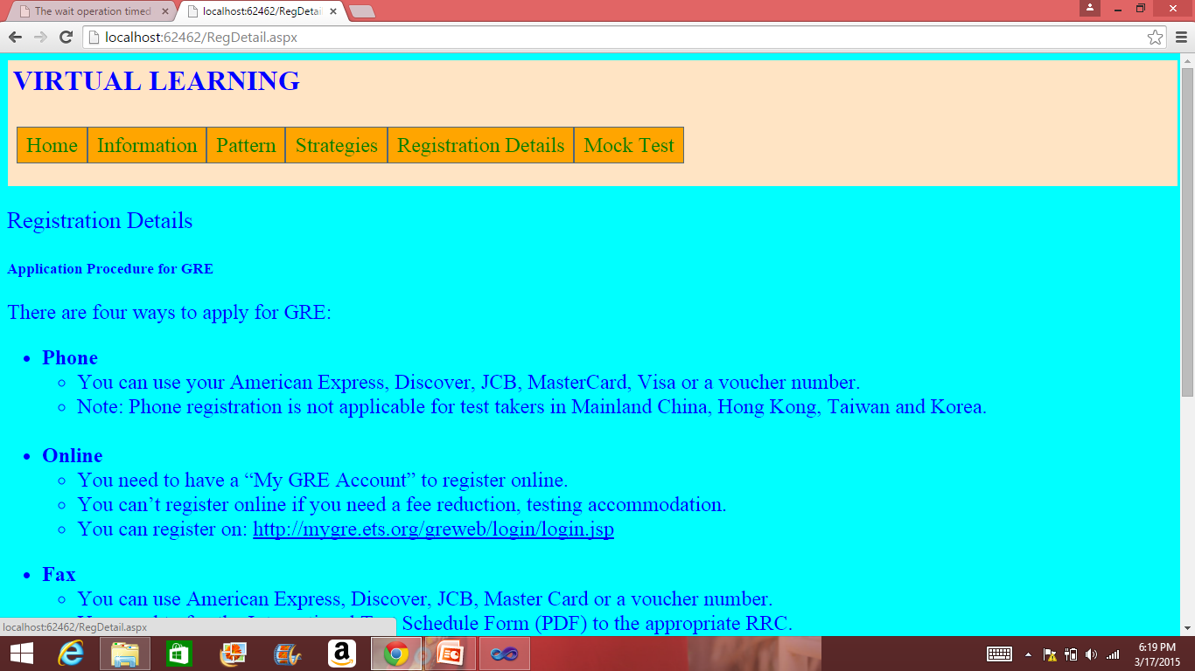

Registration Details for GRE

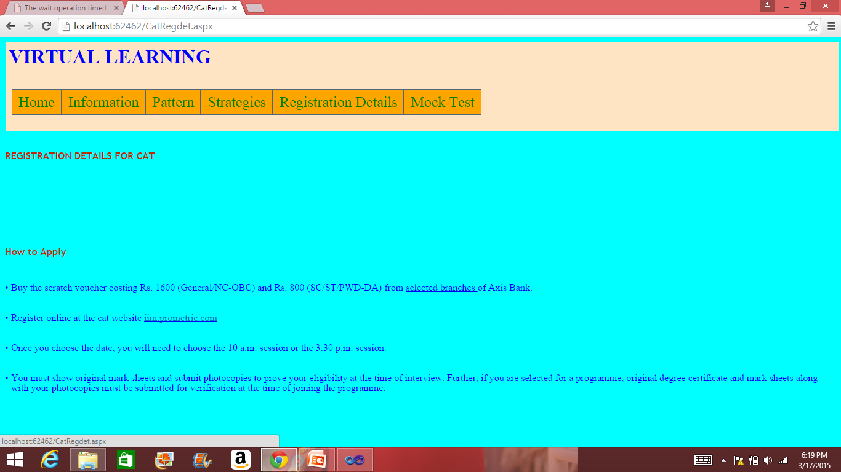

Registration details for CAT

1. **Mock Tests:**

We are providing mock tests to help the users to better understand the original test. It will have ten bits which will be selected dynamically by the system. After completing the mock test-1 the user will be directed to mock test-2 which again have ten more bits which are different from test-1. Time will be allotted to each test of about ten minutes. Upon completion of the test user will be provided with the results.

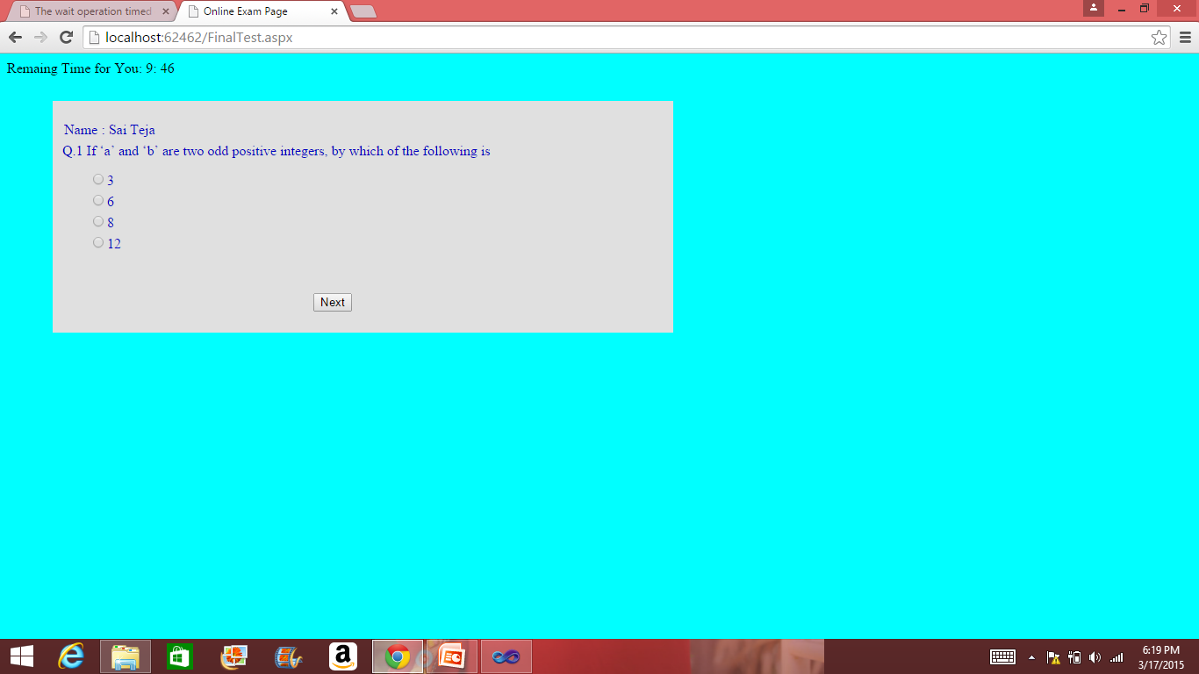

1. **Testing:**
2. **Test Case-I:**

* The test case ID is login.
* The preconditions that are to be considered are enter the login ID, enter password, and then select the user type whether admin or student.
* The description is if the login ID and password matches then home page will be displayed.
* There are four test steps which have to be done. They are entering login ID must be entered, next password must be entered, next we need to enter user type and then finally click on the login button.
* The expected output is user’s home page has to be displayed.
* The actual output is user’s home page.
* The expected output matches to actual output. So, the status of this test is “Pass”.
* There are no remarks for this test.

1. **Test Case-II:**

* The test case ID is login failure.
* Preconditions are entering wrong login ID and wrong password.
* If a mismatch is occurred between login ID and password, then an error message is displayed.
* Test steps are entering login ID, entering password, selecting user type and finally clicking the login button.
* Expected output is an alert message is displayed.
* Actual output is displayed as invalid used id/password.
* Status of this test is “Pass”.

1. **Test Case-III:**

* The test case ID is registration.
* The preconditions that are to be considered are enter the name, user Id, password and Email.
* Description is, if any numerical or alpha-numeric numbers are entered in the place of name then an error message will be displayed.
* The following steps must be followed. Firstly user must enter user name, must enter password, finally email and must click on register button.
* Expected output is registration successful page has to be displayed.
* Actual output is the registration page is displayed.
* Status: “Pass”
* There are no remarks for this test.

1. **Deployment:**
2. **Scrum Do:**

[**https://www.scrumdo.com/projects/project/virtual-learning1/iteration/124668**](https://www.scrumdo.com/projects/project/virtual-learning1/iteration/124668)

[**https://www.scrumdo.com/projects/project/virtual-learning1/iteration/124668/board**](https://www.scrumdo.com/projects/project/virtual-learning1/iteration/124668/board)

1. **Project URLs:**

[**http://localhost:62462/GrePattern.aspx**](http://localhost:62462/GrePattern.aspx)

[**http://localhost:62462/GreInfot.aspx**](http://localhost:62462/GreInfot.aspx)

[**http://localhost:62462/CatInformationpage.aspx**](http://localhost:62462/CatInformationpage.aspx)

[**http://localhost:62462/Catpattern1.aspx**](http://localhost:62462/Catpattern1.aspx)

[**http://localhost:62462/Catpattern2.aspx**](http://localhost:62462/Catpattern2.aspx)

[**http://localhost:62462/CatPatternpage.aspx**](http://localhost:62462/CatPatternpage.aspx)

[**http://localhost:62462/CatRegdet.aspx**](http://localhost:62462/CatRegdet.aspx)

[**http://localhost:62462/EnterQuestions.aspx**](http://localhost:62462/EnterQuestions.aspx)

[**http://localhost:62462/strategies.aspx**](http://localhost:62462/strategies.aspx)